Section2summary

# Summarizing section 2 by race, age group and insurance from suveys up until 2/28

### Library for code

Attaching package: 'dplyr'

The following objects are masked from 'package:stats':  
  
 filter, lag

The following objects are masked from 'package:base':  
  
 intersect, setdiff, setequal, union

── Attaching packages ─────────────────────────────────────── tidyverse 1.3.2 ──  
✔ ggplot2 3.4.0 ✔ purrr 0.3.5  
✔ tibble 3.1.8 ✔ stringr 1.5.0  
✔ readr 2.1.3 ✔ forcats 0.5.2  
── Conflicts ────────────────────────────────────────── tidyverse_conflicts() ──  
✖ dplyr::filter() masks stats::filter()  
✖ dplyr::lag() masks stats::lag()  
  
Attaching package: 'data.table'  
  
  
The following object is masked from 'package:purrr':  
  
 transpose  
  
  
The following objects are masked from 'package:dplyr':  
  
 between, first, last  
  
  
Loading required package: lattice  
  
Loading required package: survival  
  
Loading required package: Formula  
  
  
Attaching package: 'Hmisc'  
  
  
The following objects are masked from 'package:dplyr':  
  
 src, summarize  
  
  
The following objects are masked from 'package:base':  
  
 format.pval, units  
  
  
here() starts at /Users/jacobmatta/Documents/R/ASU-Project-  
  
  
Attaching package: 'DescTools'  
  
  
The following objects are masked from 'package:Hmisc':  
  
 %nin%, Label, Mean, Quantile  
  
  
The following object is masked from 'package:data.table':  
  
 %like%

### Loading the survey data until 2/28

## Cleaning

### removing the space betweem health insurance variable name

### for the analysis you only need the questions regarding race, age and insurance as well as section 2 questions

### changing numeric responses to characters for data summary and doing this so we do not have to turn to the codebook for interpretation

### Summary for race, age and insurance

freq perc  
   
African American 665 91.9%  
Asian 4 0.6%  
Caucasian 16 2.2%  
Latino or Hispanic 4 0.6%  
missing 29 4.0%  
Other 6 0.8%

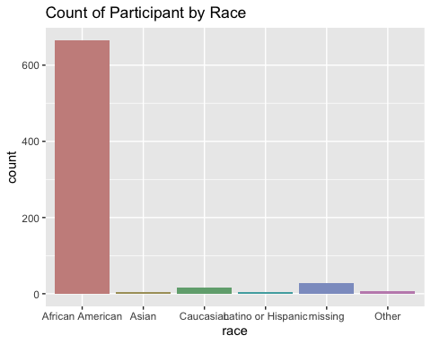

freq perc  
   
18-24 years old 146 20.2%  
25-34 years old 92 12.7%  
35-46 years old 23 3.2%  
45-54 years old 87 12.0%  
55-64 years old 126 17.4%  
65-74 years old 104 14.4%  
75 years or older 29 4.0%  
missing 117 16.2%

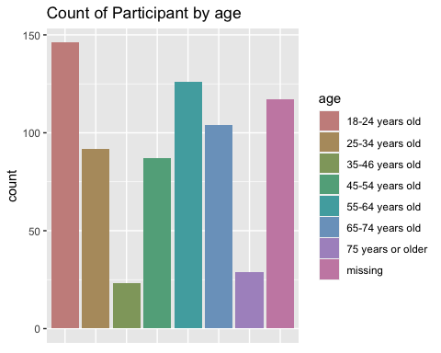

freq perc  
   
Affordable Care Act (Obamacare) 23 3.2%  
Don't Know / Not Sure 53 7.3%  
Medicaid 140 19.3%  
Medicare 114 15.7%  
missing 134 18.5%  
Other 97 13.4%  
Private Health_Insurance 132 18.2%  
Uninsured 31 4.3%

